1. Create a Instructor table with (ID, name, dept_name, salary) attributes and insert the values into Instructor table.

**Approach 1:**  insert into *sub* values(123,'swamy',' cse','90000');

**Approach 2**

Hint: Refer below procedure for inserting data into table

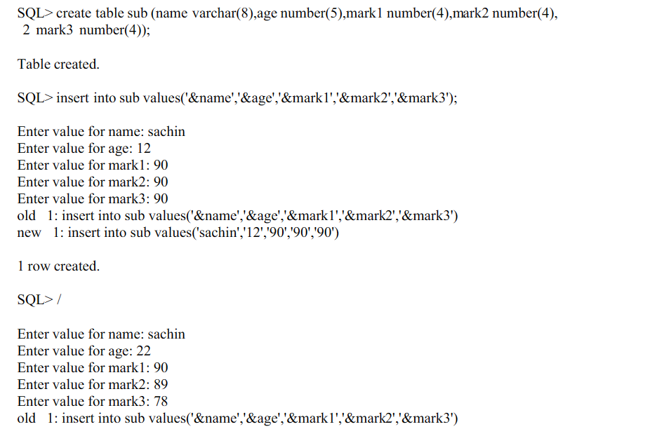

1. Create the below department relation and insert the data using above procedure

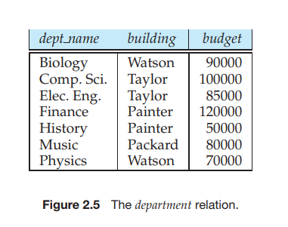

1. Modify the table names as dep and instr
2. Add a extra column in the dep table called dep_id
3. View the dep table data (Note your observations)
4. Drop the dep-id column
5. View the dep table data
6. Update the department name computer.sci as CSE
7. Delete the physics department details
8. How do you view the data dictionary?
9. How do you remove the data using delete and truncate commans ?state your observations?